Literacy support worksheet answers

6.1 The universe was studied by early Australians

Pages 140–141

Indigenous astronomy

1 What is a constellation?

A constellation is a group of stars that form a picture in the night sky.

2 Read the information below and answer parts a and b.

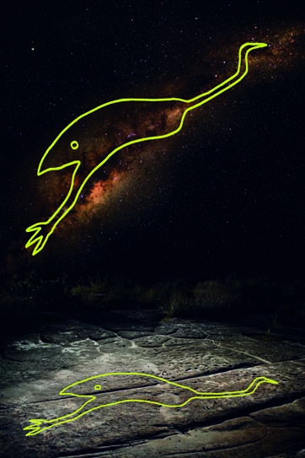

To the people living in the western desert, the emu constellation was part of their calendar. Its position helped them to know when to hunt or collect eggs.

a When the emu was running, what was it time for?

It was time to hunt emus.

b When the emu was sitting, what was it time for?

It was time to collect emu eggs.

3 The emu constellation is actually a part of which galaxy?

The Milky Way

Word detective – Draw and explain

4 Draw and explain an experience or outdoor activity that has a special meaning for you, on the pictogram of the Southern Cross below. It may be something that you like to do at particular times of the year, perhaps with family or friends. (Some examples could include camping, water skiing, surfing, fruit picking, bushwalking, certain sports or holidays).

*Student answers will vary.*

Literacy support worksheet answers

6.2 The Earth is in the Milky Way

Pages 142–143

Stellar magnitudes, parallax and distances

1 What are stars?

Stars are large balls of gas

2 Name three features that can make stars different from each other.

• temperature

• brightness

• size

• mass

3 What two elements are stars made of?

Hydrogen and helium

4 Use the following word list to fill in the blanks in the paragraph below.

Word list: close, positive, dimmer

The apparent magnitude scale is a measure of how bright a star ‘appears’ to be. The more positive (and the less negative) the number, the dimmer the star. A star may appear to be quite bright because it is close to the Earth; it may not actually be very bright.

5 The colour of a star is an indicator of its surface temperature. Complete the following sentences.

a ‘The hotter the surface temperature of the star, the bluer the colour.’

b ‘The colder the surface temperature of the star, the redder the colour.’

6 What is one method of measuring stars using colour?

The Hertzsprung–Russell diagram

7 How long does it take for the light from the Sun to reach:

a the Earth?

500 seconds or approximately 8 minutes

b Proxima Centauri?

4.2 years

8 Our Sun has a surface temperature of about 5700 K and an absolute magnitude of 4.77. Use this information to show where our Sun would be positioned on the Hertzsprun–Russell diagram below.

As shown on the accompanying diagram, our Sun sits on the main sequence of stars.

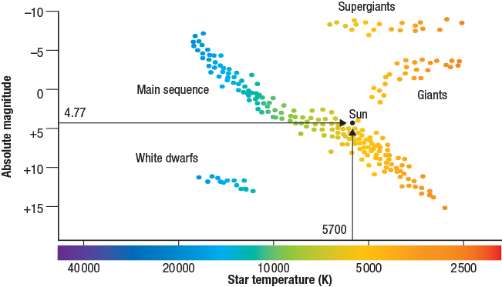

Word detective – True or false

9 Read the statement and circle whether it is true or false.

a Gases reacting at the core of a star provide energy to the star. T or F

b Nuclear fusion occurs when two atomic nuclei are repelled. T or F

c The Sun is the brightest object in the sky. T or F

d Luminosity refers to how bright a star appears to be. T or F

e Light-years measure the distance of stars from the Sun. T or F

f Proxima Centauri is the next closest star to the Earth, after the Sun. T or F

g Every night our stars and planets move across the night sky. T or F

Literacy support worksheet answers

6.3 Stars have a life cycle

Pages 144–145

Stellar evolution

1 This image shows what happens with an initial mass greater than eight solar masses, and a core mass greater than three solar masses.

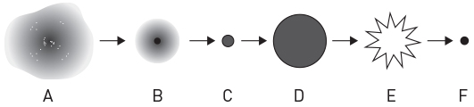

Use the following word list to correctly identify each of the stages (A to F) in a star's life cycle below. (Hint: Use Figure 6.10 in the student book as a guide.)

Word list: supernova, protostar, gas and dust, red giant star, neutron star, main sequence

|  |  |  |  |
| --- | --- | --- | --- |
| Stage | Word | Stage | Word |
| A | gas and dust | D | red giant star |
| B | protostar | E | supernova |
| C | main sequence | F | neutron star |

2 In about 5 billion years from now, our Sun will form a red giant star through the fusion of helium atoms. Because of its size, the Sun will swallow up which four planets?

• Mercury

• Venus

• Mars

• Earth

3 Our Sun is a main sequence star in hydrostatic equilibrium. There are two opposing forces that have become balanced so that the Sun is a consistent size. What are these forces?

• The release of energy forcing the gas particles out.

• The force of gravity, pulling the atoms in.

Word detective – Story board

4 Create a story board or cartoon strip showing the changes that occur during the life cycle of a star.

*Student cartoons will vary but should include information and images from star birth to death.*

Literacy support worksheet answers

6.4 The galaxies are moving apart

Pages 146–147

Spectra, the Doppler effect and galactic motion

1 Look at Figure 6.14 in the student book and observe a continuous spectrum, an emission spectrum and an absorption spectrum. Use this information, and the diagram below, to help you answer the questions below.

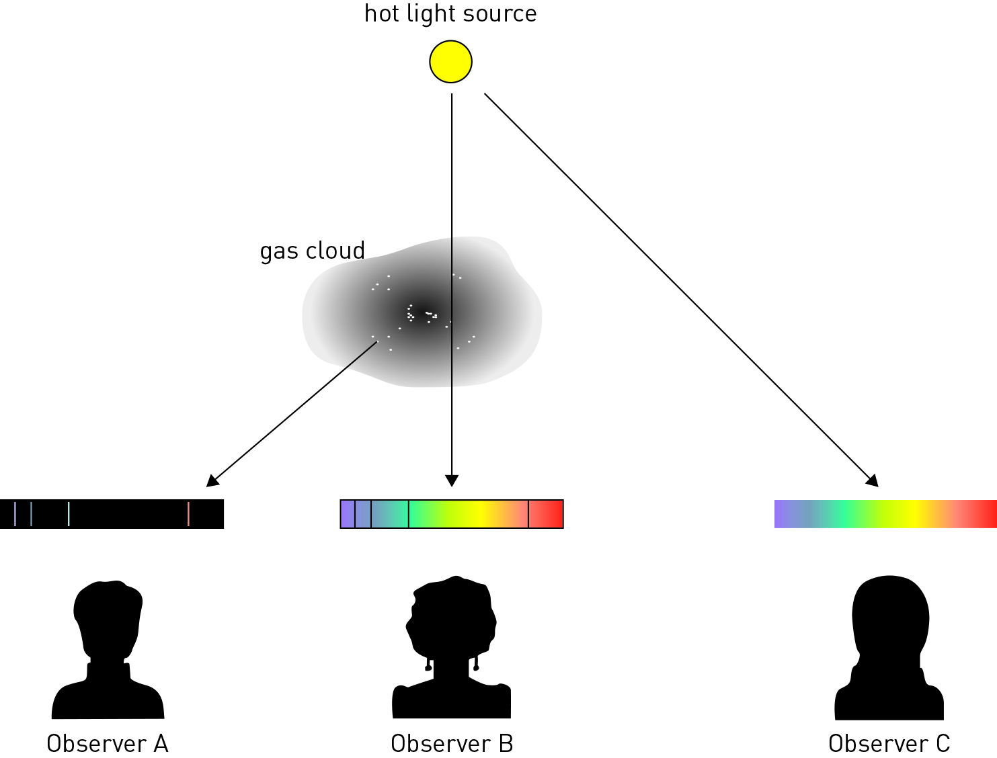

In the diagram above, which observer would see:

a a continuous spectrum?

Observer C will see a continuous spectrum.

b an emission spectrum?

Observer A will see an emission spectrum.

c an absorption spectrum?

Observer B will see an absorption spectrum.

2 What is the Doppler effect?

A change in a frequency of a wave as an object moves towards or away from an observer.

3 What did Hubble discover about a distant star besides the spectra of light emitted by galaxies?

He discovered its velocity.

4 Observe Figure 6.15 in the student book.

Star A shows a star that isn’t moving towards or away from us.

Star B shows that compared to Star A above, the lines have moved slightly right, towards the red wavelength, which means that the galaxy is moving away from the Earth.

Star C shows that the lines have moved slightly to the left, towards blue, compared to Star A which means that the galaxy is moving towards the Earth.

|  |  |
| --- | --- |
| L:\1. Publishing and Editorial\1. Product\Oxford Science\Oxford Science 10\3. Extras\14. LSW\Artwork\Final jpgs\LSW0607_01095.jpg  Figure 1 | L:\1. Publishing and Editorial\1. Product\Oxford Science\Oxford Science 10\3. Extras\14. LSW\Artwork\Final jpgs\LSW0608_01095.jpg  Figure 2 |
| L:\1. Publishing and Editorial\1. Product\Oxford Science\Oxford Science 10\3. Extras\14. LSW\Artwork\Final jpgs\LSW0609_01095.jpg  Figure 3 | L:\1. Publishing and Editorial\1. Product\Oxford Science\Oxford Science 10\3. Extras\14. LSW\Artwork\Final jpgs\LSW0610_01095.jpg  Figure 4 |

Observe Figures 1, 2, 3 and 4 above and answer the questions below.

Figure 1 shows a spectrum for hydrogen obtained in the laboratory.

Which one of Figures 2 to 4 best represents the hydrogen spectrum for a galaxy that is heading towards Earth? Explain your answer.

Figure 3 best represents the hydrogen spectrum for a galaxy that is heading towards us as due to the Doppler effect the wavelengths of its absorption lines should be shorter, i.e. they have been blue shifted.

Word detective – Draw and label

5 Draw a diagram demonstrating the Doppler effect and label the sound wave frequencies.

(Hint: Use Figure 6.13 in the student book as a guide.)

Student diagrams will vary, but will include similar diagrams to those in Figure 6.13 and should include labels of low and high frequency.

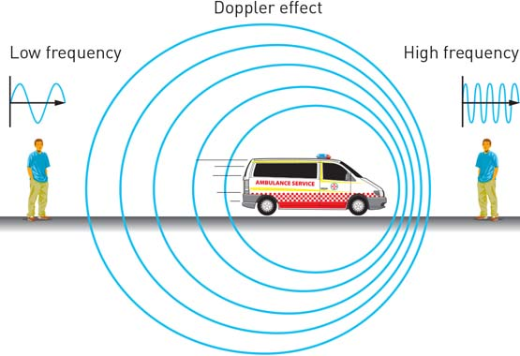

Literacy support worksheet answers

6.5 The Big Bang theory is supported by evidence

Pages 148–149

Our expanding universe

1 What is the Big Bang Theory?

A theory that describes how the universe developed from a small dense singularity into the massively expanded space it is today.

2 Complete the table below to show three pieces of evidence that support the Big Bang Theory.

|  |  |
| --- | --- |
| Evidence 1: | The presence of microwave background radiation. |
| Evidence 2: | The proportion of lighter mass elements such as hydrogen. |
| Evidence 3: | The observations of distant galaxies that provide a glimpse into the past. |

3 In 1965, two US scientists found that leftover energy existed as background radiation. What was the energy left over from?

The Big Bang

4 What award were these scientists given for their discovery?

A Nobel Prize

5 When we look at far away galaxies, we can look back in time. How is this possible?

The light from other galaxies takes a very long time to get to Earth, so scientists can see old galaxies that developed millions of years ago.

Word detective – Complete the sentence

6 Use the following word list to fill in the blanks in the sentences below.

Word list: singularity, Hubble, cooled, evidence, expanding

a The fact that galaxies are moving further away from us shows that the universe is expanding.

b The universe has cooled since the Big Bang.

c Scientists believe the universe began from a single hot point called a singularity.

d Hubble discovered that space is expanding and taking galaxies with it.

e The Big Bang theory is supported by many forms of evidence.

Literacy support worksheet answers

6.6 Technology aids cosmological research

Pages 150–151

Cosmological research

1 What is the name of the $160-million-dollar project being built in Western Australia?

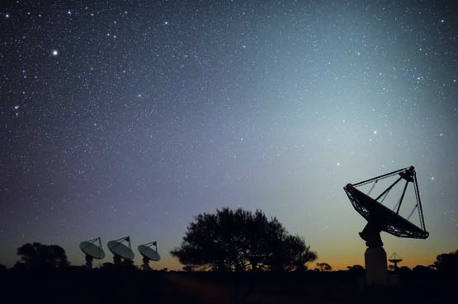

Australian Square Kilometre Array Pathfinder

2 Complete the following sentence:

‘The project has seen the installation of 36 huge antenna dishes on Boolardy Station, which will

eventually work together to survey large areas of sky to help scientists understand

how galaxies have formed and evolved.’

3 Use the following word list to fill in the blanks in the paragraph below.

Word list: millions, holes, universe, telescopes, galaxies, survey

The latest picture we’ve taken has almost 2000 galaxies in it, which is incredible,’ she said. ‘It’s kind of a wide field image in the sky. Once we’ve got 36 telescopes we’ll be able to do a huge survey of the entire night’s sky and see millions of new galaxies, black holes and things in the very distant universe that no one’s ever seen before.’ – Lisa Harvey-Smith

4 Name two things that scientists have been able to observe so far.

• galaxies older than our Earth

• radio waves being emitted from objects in outer space

5 Project director Antony Schinckel said ‘There are still huge holes in our knowledge…’

Name three things he thinks we still have to discover.

• How our universe evolved.

• Where galaxies come from.

• How planets form.

Word detective – Write a postcard

6 Imagine you have just been on a tour of the ASKAP.

Write a postcard to one of your friends, explaining what you have learned about the telescope.

*Student postcards will vary.*